##### Semester Two Examination, 2012

**Answer key**

CHEMISTRY

**Stage 3**

**Section One: Multiple-choice 25% (50 marks)**

|  |  |  |  |
| --- | --- | --- | --- |
| 1 | B | 14 | A |
| 2 | A | 15 | B |
| 3 | A | 16 | B |
| 4 | C | 17 | D |
| 5 | C | 18 | B |
| 6 | A | 19 | D |
| 7 | C | 20 | C |
| 8 | C | 21 | C |
| 9 | D | 22 | C |
| 10 | D | 23 | D |
| 11 | D | 24 | B |
| 12 | B | 25 | B |
| 13 | A |  |  |

**Section Two: Short answer 40% (80 Marks)**

**Question 26 (9 marks)**

For each species listed in the table below, draw the Lewis structure, representing all valence shell electron pairs either as : or as — **and** state or sketch the shape of the species **and** state the polarity of the molecule.

|  |  |  |  |  |  |  |
| --- | --- | --- | --- | --- | --- | --- |
| (for example, water |  | or |  | or |  | bent, polar) |

|  |  |  |  |
| --- | --- | --- | --- |
| **Species** | **Structure (showing all valence electrons)** | **Shape (sketch or name)** | **Polarity of molecule (polar or non-polar)** |
| Hydrogen cyanide  HCN |  | **Linear** | **Polar** |
| Difluoromethane  CH2F2 |  | **Tetrahedral** | **Polar** |
| Sulfur trioxide  SO3 |  | **Trigonal/Triangular Planar** | **Non-Polar** |

**Question 27 (5 marks)**

Trichloroethanoic acid (CC3COOH)is a weak acid that is sometimes used in the removal of warts and tattoos. It allows new skin cells to appear by removing the first few layers of skin. The sodium salt of the acid (sodium trichloroethanoate) is also used as a weedkiller.

1. Write an equation to show the reaction that takes place when trichloroacetic acid is dissolved in water. (1 mark)

**CC3COOH + H2O CC3COO- + H3O+ (1)**

1. State and explain what would happen to the pH (increase, decrease, or no change) of a 1 mol L-1 solution trichloroethanoic acid if it were mixed sodium trichloroethanoate. (4 marks)

**Effect on pH (circle one)** **Increases** Decreases No change

Reason

**By adding sodium trichloroethanoate, we are increasing [CC3COO-]. (1)**

**System will try to lower [CC3COO-] (according to LCP) by moving LEFT. (1)**

**This causes [H3O+] to fall, and pH to rise. (1)**

**Question 28 (5 marks)**

Give the name (or formula) of the species that match each of the following descriptions.

1. The conjugate base of carbonic acid. **Hydrogencarbonate / HCO3-**  **(1)**
2. A tertiary alcohol with 4 carbon atoms. **Methyl-propan-2-ol / CH3C(CH3)OHCH3** **(1)**
3. A diatomic element with a triple bond. **Nitrogen / N2 (1)**
4. A network covalent compound. **Silicon dioxide / SiO2 or Silicon Carbide /**

**SiC or Tungsten Carbide / WC (1)**

1. A polar oxide of carbon. **Carbon monoxide / CO** **(1)**

**Question 29 (11 marks)**

1. Tribromobenzene is an important intermediate in drug manufacture, and can be made by reacting benzene (C6H6) with bromine in the presence of an aluminium bromide catalyst. Write an equation for the reaction of benzene with bromine to produce tribromobenzene. (2 marks)

**C6H6 + 3 Br2 🡪 C6H3Br3 +3 HBr**

**Correct species. (1)**

**Correctly balanced. (1)**

1. Tribromobenzene can exist as one of three isomers. Draw the structure and give the name of each of these isomers in the table below. (6 marks)

|  |  |
| --- | --- |
| **Structure** | **Name** |
|  | **1,2,3-tribromobenzene** |
|  | **1,2,4-tribromobenzene** |
|  | **1,3,5-tribromobenzene** |

1. The reaction between bromine and propene does not require a catalyst, and will occur in the dark. Write a balanced equation for the reaction and give details of what you would observe as the reaction takes place. (3 marks)

|  |  |  |
| --- | --- | --- |
| *Equation* | **Br2 + CH3CHCH2 🡪 CH3CHBrCH2Br (2)** | |
| *Observation* | | **Colourless solution mixes with orange solution, producing colourless solution (1)** |

**Question 30 (10 marks)**

Provide explanations for each of the following observations.

1. 2-bromo-2-butene exhibits geometric isomerism but 2-bromo-1-butene does not. (3 marks)

**Both molecules have a C=C bond. (1)**

**2-bromo-2-butene has two different groups at each end ot the C=C. (1)**

**2-bromo-1-butene does not have two different groups at each end of C=C. (1)**

1. Hydrogen chloride (boiling point -85°C) is a more polar molecule than hydrogen bromide, but hydrogen bromide boils at a higher temperature (-66.8°C). (3 marks)

**Polarity a result of electronegativity difference between atoms in a bond – Cl atoms more electronegative than Br, hence HCl is more polar than HBr. (1)**

**HBr has a higher molar mass, and therefore has stronger dispersion forces that HCl.(1)**

**Stronger dispersion forces (in HBr) outweigh stronger dipole-dipole forces (in HCl) in this case. (1)**

1. Sodium is a soft, malleable material, but sodium chloride is hard and brittle. (4 marks)

**Sodium’s structure is a METALLIC LATTICE, with positive ions surrounded by a sea of delocalised e-.(1)**

**Sodium chloride is an IONIC LATTICE, with positive and negative ions. (1)**

**Sodium’s ions in a metallic lattice can move without breaking bonds. (1)**

**In sodium chloride, like charged ions will be brought into contact if shape is changed, repelling each other and breaking the structure. (1)**

**Question 31 (7 marks)**

0.0100 mol L-1 potassium hydroxide was placed in a burette, and titrated against 20.0 mL aliquots of 0.0100 mol L-1 hydrofluoric acid. The pH of the solution was measured using a pH probe after the addition of each 1.00 mL of potassium hydroxide until 40.0 mL had been added. The results of the experiment are shown in the graph below:

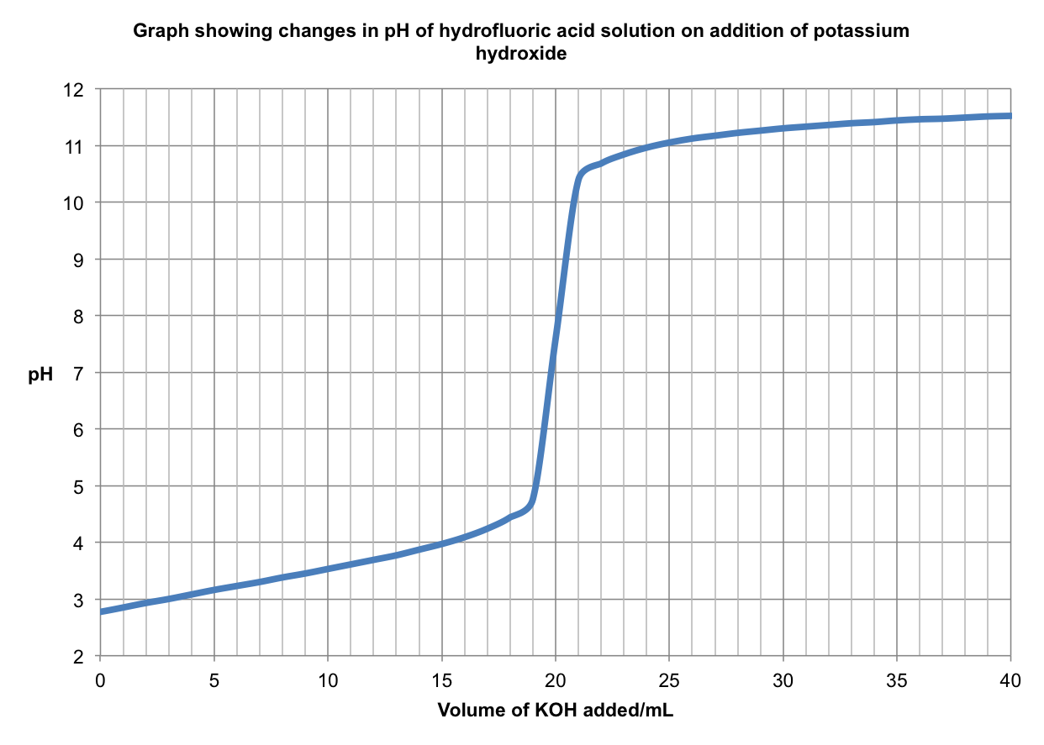

The measured pH at the start of the experiment was 2.77.

1. Determine the percentage of hydrogen fluoride molecules that were ionised. (2 marks)

**[H+] = 10-2.77**

**= 1.698 x 10-3molL-1 (1)**

**% ionised = ionised / unionised at start x 100%**

**= (1.698 x 10-3 / 0.0100) x 100%**

**= 17.0% (to 3.s.f.) (1)**

1. Explain why the pH at the equivalence point was not 7. (3 marks)

**The salt present at equilibrium is KF. (1)**

**K+ is a neutral ion, so won’t affect pH, however… (1)**

**Hydrolysis of F-: F- + H2O HF + OH-  This equation shows the overall formation of a basic solution, which explains why the pH at equivalence is >7. (1)**

A similar experiment was carried out to determine the concentration of ethanoic acid in a verruca remedy (verrucas are similar to warts, and are commonly found on the feet). A solution of the remedy was prepared by dissolving a 5.00 mL portion in water and making the solution up to

250 mL in a volumetric flask. 20.0 mL aliquots of it were titrated against the same solution of potassium hydroxide. The experiment was carried out without a pH probe, using methyl orange as an indicator.

1. Explain what effect this choice of indicator would have on the calculated value of the acid concentration. (2 marks)

**Methyl orange would change before the equivalence point, meaning less OH- would be used to ‘neutralise’ the acid than necessary. (1)**

**Gives LOWER ethanoic acid concentration than true value. (1)**

**Question 32 (4 marks)**

Give the IUPAC name of the following compounds.

|  |  |
| --- | --- |
| **Formula** | **Name** |
| CH3(CH2)5CH(OH)CH3 | **2-octanol or octan-2-ol** |
| CH3CH2COOCH2CH3 | **ethyl propanoate** |
| CH3CH2COCH2CH3 | **pentan-3-one or 3-pentanone** |
| CH3CH2CH2CHO | **butanal** |

**Question 33 (6 marks)**

In an experiment designed to investigate the effect of sweating on body temperature, a student wrapped the bulb of a thermometer in tissue paper, and then dipped this in water. The thermometer was removed from the water, and held in a breeze from a nearby fan. After a short time, the student noticed that the paper had dried out, and that the temperature on the thermometer had fallen.

1. Explain, in terms of kinetic theory, why the temperature fell during the experiment. (3 marks)

**A certain proportion of particles possess enough energy to escape from the surface of the liquid (evaporate). (1)**

**As these particles evaporate, lower energy particles are left behind in the liquid, causing the average kinetic energy of particles in the liquid to fall. (1)**

**Since temperature is proportional to the average kinetic energy of particles, the temperature of the liquid falls. (1)**

The experiment was then repeated, but the thermometer was dipped in sodium chloride solution instead of water.

1. State and explain how the temperature change would be expected to differ from the first experiment. (3 marks)

**Strong ion-dipole forces exist between water molecules and sodium/chloride ions in the solution. (1)**

**These forces increase the energy required for liquid particles to evaporate. (1)**

**Evaporation takes place more slowly, and the temperature change is smaller than that for pure water. (1)**

**Question 34 (13 marks)**

Kevlar is a synthetic fibre used in windsurfing sails and bulletproof vests. Like Nylon and Rayon, it is a condensation polymer, but its breaking strength is around ten times that of Nylon. The structure of Kevlar is shown below, with its repeating unit in bold.

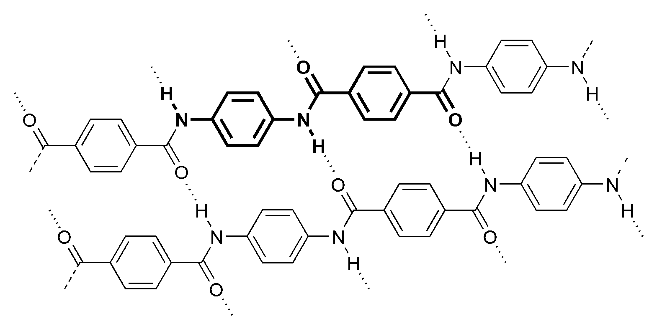

1. Draw the structure of two monomers that could be used to make Kevlar.

(2 marks)

|  |  |
| --- | --- |
| **Monomer 1** | **Monomer 2** |
|  |  |

Polyvinyl alcohol (PVA) is an unusual addition polymer, in the sense that it is not made by building up single-precursor molecules known as monomers. Instead, it is made by hydrolysing another polymer, polyvinyl acetate. This polymer is built up using the monomer vinyl acetate, whose formula is CH3COOCHCH2, and whose skeletal formula is shown below.

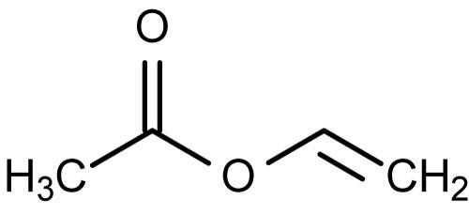

1. Identify any functional groups present in this molecule by **circling** them and **naming** them on the skeletal formula. (2 marks)

**Ester Alkene**

1. In the space below, draw the structure of a length of polyvinyl acetate that would form from three vinyl acetate molecules. (2 marks)

|  |  |  |  |  |  |  |  |  |
| --- | --- | --- | --- | --- | --- | --- | --- | --- |
|  | **H** | **H** |  | **H** | **H** |  | **H** | **H** |
|  | **I** | **I** |  | **I** | **I** |  | **I** | **I** |
| **----** | **C -------** | **C** | **---** | **C -------** | **C** | **---** | **C -------** | **C -------** |
|  | **I** | **I** |  | **I** | **I** |  | **I** | **I** |
|  | **OOCCH3** | **H** |  | **OOCCH3** | **H** |  | **OOCCH3** | **H** |

**Correct repeating unit (acetate groups need not all be on one side) (1)**

**Correct chain length (1)**

The process of hydrolysis involves dissolving the polyvinyl acetate in methanol, and then reacting it with sodium hydroxide.

1. Use your knowledge of intermolecular forces to explain why polyvinyl acetate is soluble in methanol. You may use a diagram to aid your explanation. (2 marks)

**H-bonds can form between C=O groups of PVA and OH groups of methanol (or drawn). (1)**

**These strong forces overcome the forces broken when the solvent dissolves the solute.(1)**

1. Write an equation to represent the reaction between sodium hydroxide and vinyl acetate.

(2 marks)

**CH3COOCHCH2 + OH- 🡪 CH3COO- + CH2CHOH**

**Correct species (1)**

**Balanced (1)**

Early in 2012, chemists working at Hanyang University in Korea were able to synthesise the toughest polymer yarn known at the time by mixing PVA with carbon nanotubes (CNTs) during the spinning of the yarns. One type of fibre, which was manufactured using PVA (polyvinyl alcohol) and single-walled carbon nanotubes (SWCNTs), had a toughness of 870 J/g, making it far stronger than spider silk (165 J/g) and more than ten times as strong as Kevlar (78 J/g).

|  |  |
| --- | --- |
|  | Carbon nanotubes are an allotrope of carbon whose structure is shown in the picture, and is similar to that of graphite. They were discovered in 1991 as a spin-off from research into Buckminsterfullerenes, and have since found uses in a huge variety of applications, from medicine to electronics and molecular manufacturing. |

1. With reference to the structure and bonding present, explain whether or not you would expect carbon nanotubes to be able to conduct electricity. (3 marks)

**3 bonds to each carbon, using 3 e-s. (1)**

**1 e- from each carbon not used in bonding. (1)**

**Delocalised electrons can move and carry charge, so it conducts electricity. (1)**

**End of Section TwoSection Three: Extended answer 40% (80 marks)**

This section contains **five (5)** questions. You must answer **all** questions. Write your answers in the spaces provided.

Where questions require an explanation and/or description, marks are awarded for the relevant

chemical content and also for coherence and clarity of expression.

Final answers to calculations should be expressed to three (3) significant figures and include appropriate units.

Spare pages are included at the end of this booklet. They can be used for planning your

responses and/or as additional space if required to continue an answer.

* Planning: If you use the spare pages for planning, indicate this clearly at the top of the page.
* Continuing an answer: If you need to use the space to continue an answer, indicate in the

original answer space where the answer is continued, i.e. give the page number. Fill in the

number of the question(s) that you are continuing to answer at the top of the page.

Suggested working time: 70 minutes*.*

**Question 34 (21 marks)**

|  |  |
| --- | --- |
| The diagram shows a fuel injector of the type used in many combustion engines. The engine management system causes the needle valve to open and then close, ensuring that a precise amount of fuel enters the cylinder. The fuel enters the cylinder as a fine mist, and mixes with air. The cylinder then compresses the fuel-air mixture to around one tenth of its original volume  Modern combustion engines running on unleaded petrol use fuel composed mainly of octane and isomers of octane. The research octane number (RON) gives an indication as to the composition of the mixture |  |

1. One common isomer of octane present in petrol is 2,2,4-trimethylpentane. State and explain how you would expect the boiling points of octane and 2,2,4-trimethylpentane to compare. (3 marks)

**Octane should have the higher boiling point. (1)**

**Less branching in octane means molecules are closer together in liquid state in octane. (1)**

**Dispersion forces act over shorter distances in octane, and are stronger as a result, meaning more energy required to separate molecules. (1)**

1. Write a balanced equation for the complete combustion of octane. (2 marks)

**2 C8H18 + 25 O2 🡪 16 CO2 + 18 H2O**

**Correct species (1)**

**Correct balancing (can be halved) (1)**

1. Using collision theory, explain the effect on the rate of the combustion reaction of the following.
   1. Injecting the fuel as a fine mist. (2 marks)

**Increased surface area. (1)**

**More particles exposed to collisions so more frequent collisions and higher rate of reaction. (1)**

* 1. Compressing the air-fuel mixture prior to ignition. (2 marks)

**Increased no of particles per unit volume. (1)**

**More collisions per second leads to higher rate of reaction. (1)**

1. At a normal engine operating temperature of 1000°C, an injector injects 1.00 g of fuel for every 60.0 litres of air entering the cylinder at atmospheric pressure. Assuming all the components of the fuel have the molecular formula C8H18, and that air is exactly 20% oxygen by volume, find the limiting reagent. (5 marks)

**n(C8H18) = m/M = 1 / (12.01 x 8 + 18 x 1.008) = 8.75 x 10-3 mol (1)**

**V(O2) = 60/5 L = 12 L (1)**

**n(O2) = pV/RT = 101.3 x 12 / (8.314 x 1273.15) = 0.115 mol (1)**

**mole ratio (from equation), octane : oxygen = 2 : 25 = 0.08**

**ratio of reactants, octane : oxygen = 8.75 x 10-3 : 0.115 = 0.0762**

**0.0762 < 0.08, so octane is LR (1)**

1. Calculate the mass of any unused reactant from the above reaction mixture. (2 marks)

**n(O2) remaining = 0.115 – (8.75 x 10-3 x 25/2) = 5.41 x 10-3 mol (1)**

**m(O2) = n x M = 5.41 x 10-3 x 32 = 0.173 g (1)**

Since regulations governing emissions from motor vehicles have become stricter, fuel injection technology is found on most newly manufactured vehicles, owing to the fact that it significantly reduces the occurrence of incomplete combustion.

1. With reference to the products of the reaction, explain why it is important to prevent this reaction occurring. (2 marks)

**Incomplete combustion forms carbon monoxide. (1)**

**Carbon monoxide is poisonous to humans (soot can cause lung disease). (1)**

**Or**

**Incomplete combustion produces soot. (1)**

**Soot causes irritation of the lungs (lung disease). (1)**

As concern over the effect of burning fossil fuels mounts, alternatives are being sought to the internal combustion engine.

|  |  |
| --- | --- |
| The photograph shows a proton exchange membrane (PEM) fuel cell, capable of offering outputs of up to 250 kW. Whilst not as efficient as some other designs of fuel cell, this type of cell offers the advantage that it runs at low temperatures and consists of a solid, flexible electrolyte that will not leak. As a result, this type of fuel cell is particularly well suited to use in automotive applications. The cell uses hydrogen as its fuel, which is combined with oxygen to produce water. |  |

1. State the cell voltage that can be obtained from a single fuel cell such as this. (1 mark)

**1.23 V**

1. State TWO environmental advantages of the use of fuel cells to power motor vehicles, compared to combustion engines. (2 marks)

**Only product is water – no carbon dioxide or polluting gases. (1)**

**Uses renewable reactants – no fossil fuels consumed. (1)**

**Question 35 (24 marks)**

A student conducted a series of experiments to investigate the physical and chemical properties of basic solutions. In the first experiment, she made a solution by dissolving 10.0 g of barium hydroxide in 250 mL of water.

1. Calculate the pH of this solution. (5 marks)

**n(Ba(OH)2) = m/M = 10.0 / (137.3 + 16 x 2 + 1.008 x 2) = 10.0 / 171.316 = 5.84 x 10-2 mol (1)**

**n(OH-) = 2 x 5.84 x 10-2 = 0.116 mol (1)**

**[OH-] = 0.116 / 0.250 = 0.467 mol L-1 (1)**

**[H+] = 10-14 / 0.467 = 2.14 x 10-14 (1)**

**pH = -log (2.14 x 10-14) = 13.7 (1)**

1. During the experiment, the conductivity of the solution was measured. It was observed to be high at the start of the experiment. As the acid was added, it fell to zero and then increased again. Explain these observations. (4 marks)

**Barium hydroxide is a strong electrolyte – solution contains mobile charge carriers (ions) which can conduct. (1)**

**Adding sulfuric acid forms barium sulfate, which is insoluble, and water, which does not dissociate well. (1)**

**Very few ions to conduct electricity when acid neutralises the barium hydroxide. (1)**

**Adding more sulfuric acid (strong electrolyte) places ions in solution, enabiling it to conduct again. (1)**

Wanting to carry out experiments on basic solutions found outside of the laboratory, the student decided to investigate milk of magnesia. Reading the information on the label, the student realised that this was a saturated solution of magnesium hydroxide in water. The mixture gets its name from the fact that undissolved solid is suspended in the liquid, giving it a milky appearance.

In the mixture, the following reaction takes place:

Mg(OH)2(s) Mg2+(aq) + 2OH-(aq)

1. Write an expression for the equilibrium constant, K, for the above reaction. (1 mark)

**K = [Mg2+] x [OH-]2 (1)**

1. Explain whether you would you expect the value of K to be greater than one (> 1) or less than one (< 1). (2 marks)

**Less than one.**

**Magnesium hydroxide is insoluble. (1)**

**Concentration of ions will be v. small, meaning [Mg2+] x [OH-]2 will also be v. small. (1)**

The student wanted to know whether the mass of solid present in the mixture could be affected by various changes. The mixture was divided equally amongst four beakers, and the student filtered the mixtures after each experiment to find the mass of undissolved magnesium hydroxide. One beaker was left unchanged to act as a control.

1. For each of the changes described below, predict and explain what effect the change would have on the mass of solid present once the system had returned to equilibrium.
2. Distilled water was added to the mixture. (3 marks)

|  |  |  |  |
| --- | --- | --- | --- |
| **Effect on mass of solid**  **(circle one)** | INCREASE | **DECREASE** | NO CHANGE **(1)** |

Explanation

**[Mg2+] and [OH-] both fall as water is added. (1)**

**System acts to increase [Mg2+] and [OH-] (according to LCP) – forward reaction favoured (consumes solid). (1)**

1. A few drops of vinegar were added to the mixture. (3 marks)

|  |  |  |  |
| --- | --- | --- | --- |
| **Effect on mass of solid**  **(circle one)** | INCREASE | **DECREASE** | NO CHANGE **(1)** |

Explanation

**Vinegar (acid) reacts with OH-, reducing [OH-]. (1)**

**System tries to increase [OH-], by favouring forward reaction, which consumes solid. (1)**

The student put a third beaker in the fridge. When he removed it, he noticed that the mass of solid had increased compared to the control beaker.

1. Explain what information this gives us about the enthalpy of the products of the reaction compared to that of the reactants. (3 marks)

**Enthalpy of products HIGHER than reactants. (1)**

**Lowering T will favour the EXOTHERMIC process (according to LCP). (1)**

**Hence backward reaction (which produces solid) must be exothermic. (1)**

**Question 36 (14 marks)**

In order to find the formula of hydrated copper(II) sulfate, CuSO4.*n*H2O, 5.02 g of the hydrated sulfate was dissolved in water, and the solution made up to 100 mL. To this solution was added excess potassium iodide, forming iodine according to the following equation:

2Cu2+(aq) + 4I-(aq) 🡪 2CuI(s) + I2(aq)

1. Use the concept of oxidation numbers to show which species were oxidised and reduced in this process. (3 marks)

**Cu from +2 to +1 (1)**

**I from -1 to 0 (1)**

**Copper(II) reduced, Iodide oxidised. (1)**

10.0 mL portions of the resulting solution containing iodine were titrated using 0.100 mol L-1 sodium thiosulfate solution (Na2S2O3), 20.02 mL being required for complete reaction. In this titration, thiosulfate ions reduce iodine to iodide, and are converted to tetrathionate ions (S4O62-).

1. Write ionic half-equations to show the reduction and oxidation processes taking place.

(2 marks)

|  |  |
| --- | --- |
| **Reduction** | **I2 + 2 e- 🡪 2 I- (1)** |
| **Oxidation** | **2 S2O32- 🡪 S4O62- + 2 e-(1)** |

1. Write an overall ionic equation to show the reaction between thiosulfate ions and iodine.

(1 mark)

**I2 + 2 S2O32-🡪 2 I- + S4O62-**

1. Calculate the number of moles of copper ions in the original 5.02 g sample of hydrated copper(II) sulfate. (4 marks)

**n(Cu2+) = 2 x n(I2) = n(S2O32-) (1)**

**n(S2O32-) = cv = 0.10 x 0.02002 = 0.002002 mol (1)**

**n(Cu2+) = 0.002002 mol (in 10 mL) (1)**

**n(Cu2+) = 2.00 x 10-3 x 0.100/0.0100 = 2.00 x 10-2 mol (1)**

1. Find the value of *n* in the formula of this hydrated sulfate and write its correct formula.

(4 marks)

**n(CuSO4) = 2.00 x 10-2 mol**

**m(CuSO4) = 2.00 x 10-2 x (63.55 + 32.06 + 4 x 16) = 1.001 x 10-2 x 159.61 = 3.20 g (1)**

**m(H2O) = 5.02 g – 3.20 g = 1.82 g (1)**

**n(H2O) = 1.82 / 18.016 = 0.101 mol (1)**

**n(CuSO4) : n(H2O) = 2.00 x 10-2: 0.101 1 : 5, so formula is CuSO4.5H2O (1)**

**Question 37 (18 marks)**

Amino acids are the building blocks of proteins in biological systems, as well as playing important roles as intermediates in metabolism. There are 20 naturally occurring amino acids found in proteins. Ten of these are produced within the human body. The other ten, known as *essential* amino acids, must be obtained from food. Failure to obtain sufficient quantities of these can lead to degradation of the body’s proteins. Since the body cannot store amino acids, it is therefore important that these *essential* amino acids are in food every day.

The simplest amino acid found in proteins is known as glycine. The skeletal formula of glycine is shown below.

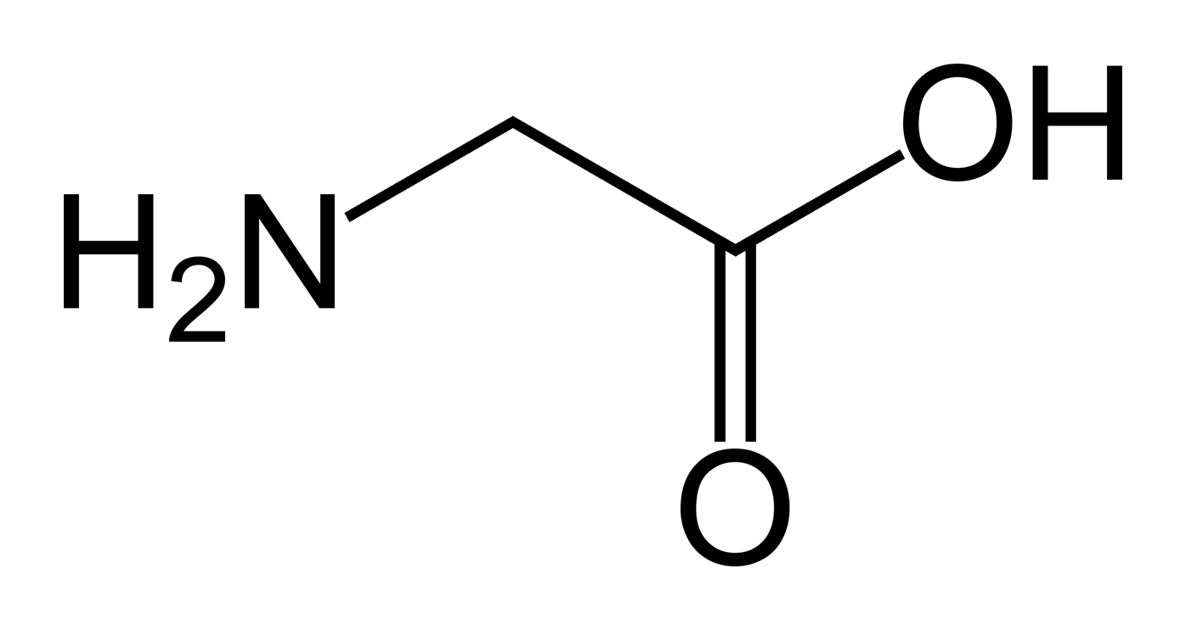

In neutral solutions, glycine is found in a *zwitterion* form. Solutions of this ion can act as buffers.

1. Draw the structure of this ion in the space below. (1 mark)

|  |  |  |  |  |  |  |  |  |
| --- | --- | --- | --- | --- | --- | --- | --- | --- |
|  |  | H |  | H |  |  |  |  |
|  |  | I |  | I |  |  |  |  |
| H | -- | N+ | -- | C | -- | C | = | O |
|  |  | I |  | I |  | I |  |  |
|  |  | H |  | H |  | O- |  |  |

1. Using equations to illustrate your answer, explain how glycine in its *zwitterion* form is able to act as a buffer. (3 marks)

**Adding H+: +NH3CH2COO- + H+ +NH3CH2COOH (1)**

**Adding OH-: +NH3CH2COO- + OH- NH2CH2COO- + H2O (1)**

**Glycine is able to absorb both H+ and OH-, and maintain pH. (1)**

Lysine is one of the ten *essential* amino acids. Elemental analysis shows that it is composed of the elements nitrogen, hydrogen, carbon, and oxygen. In an experiment to find its empirical formula, 2.175 g of lysine was combusted, producing 3.93 g of carbon dioxide and 1.87 g of water vapour. In a separate experiment, 1.986 g of lysine was reacted to turn all the nitrogen present into ammonia. It was found that 0.462 g of ammonia was formed.

1. Determine the empirical formula of lysine. (8 marks)

**m(C) = n(CO2) x 12.01 = 3.93 / 44.01 x 12.01 = 0.0894 mol x 12.01 = 1.072 g (1)**

**m(H) = 2 x n(H2O) x 1.008 = 1.87 / 18.016 x 2 x 1.008 = 0.104 x 2 x 1.008 = 0.209 g (1)**

**m(N) = n(NH3) x 14.01 = 0.462 / 17.034 x 14.01 = 0.0272 x 14.01 = 0.380 g (1)**

**%C = 1.075 / 2.175 = 49.3%**

**%H = 0.211 / 2.175 = 9.62%**

**%N = 0.381 / 1.986 = 19.1% (1)**

**%O = 100 – 49.43 – 9.70 – 19.18 = 21.9% (1)**

|  |  |  |  |  |  |
| --- | --- | --- | --- | --- | --- |
|  | **C** | **H** | **N** | **O** |  |
| **%** | **49.3** | **9.62** | **19.1** | **21.9** |  |
| **n** | **4.11** | **9.55** | **1.37** | **1.37** | **(1)** |
| **Ratio** | **3** | **6.97** | **1** | **1** | **(1)** |

**EF is C3H7NO (1)**

Another sample of lysine, weighing 2.58 g, was heated in the absence of air. It was found that the vapour occupied a volume of 549 mL at 100°C and 100 kPa.

1. Find the molecular formula of lysine (4 marks)

**n = pV/RT = 100 x 0.549 / (8.314 x 373.15) = 1.77 x 10-2 mol (1)**

**M = m/n = 2.58 / 1.77 x 10-2 = 145.8 g / mol (1)**

**‘M’ of EF = 3 x 12.01 + 7 x 1.008 + 14.01 + 16 = 73.096 g / mol (1)**

**145.8 / 73.096 $≈$ 2, so MF = 2 x EF = C6H14N2O2 (1)**

**Question 38 (8 marks)**

Primary standard solutions are important in many forms of volumetric analysis. Potassium permanganate solution (in redox titrations), hydrochloric acid solution and sodium hydroxide (in acid-base titrations) are commonly used secondary standards, and are usually standardised against primary standards before use in volumetric analysis. Examples of substances that can be used as primary standards are sodium carbonate decahydrate (Na2CO3.10H2O) and oxalic acid (C2H2O4.2H2O).

Outline how a primary standard solution could be made in the laboratory. Marks will be awarded for relevant chemical content in your answer, and also for coherence and clarity of expression. Your answer does NOT need to include any calculations.

You should include equations where relevant, and focus on the following areas:

* Important features of a primary standard;
* Why substances such as potassium permanganate, hydrochloric acid and sodium hydroxide are not suitable for use as primary standards;
* Steps taken, and equipment used in the preparation of a primary standard solution in order to minimise the potential for error.

**Primary standards should:**

* **have high molar mass. (1)**
* **be available in pure form, i.e. be stable – not react with things around them, in the atmosphere, for example (not be hygroscopic or deliquescent). (1)**

**Problems with KMnO4, HCl, and NaOH**

* **KMnO4 can turn into MnO2 when left to stand. (1)**
  + **MnO4- + 4H+ + 3e- 🡪 MnO2 + 2H2O (1)**
* **HCl will absorb atmospheric moisture, diluting it. (1)**
* **NaOH pellets are deliquescent. (1)**
* **NaOH will react with atmospheric CO2, turning into the carbonate. (1)**
  + **2 NaOH + CO2 🡪 Na2CO3 + H2O (1)**

**Any four points from the above listed (4 marks)**

**Procedure (4 marks)**

* **Accurately weigh an amount of the primary standard, such that the number of moles needed for the solution is present. (1)**
* **Dissolve in distilled water, and transfer solution to volumetric flask, ensuring equipment is thoroughly rinsed, and all washing transferred to flask. (1)**
* **Top up volumetric flask to line, using distilled water. (1)**
* **Ensure that flask is inverted several times to ensure consistent concentration of solution throughout. (1)**

**End of questions**